**Framework for Project Management**

1. Project Management as a Profession
2. The Project Management Institute (PMI)
3. Project Management Knowledge Areas
4. Project Management Certifications
5. Scrum development
6. The Project Management Office

**Project Management as a Profession**

1. Body of Knowledge
2. Standards
3. Professional organizations
4. Currently, anyone can call him or herself a project manager
5. Unresolved issue: to what extent can an expert PM move from one industry to another?

**Project Management Standards**

1. Standards organizations
2. PMI
   1. Project Management Institute: <http://www.pmi.org/>
   2. CAPM, PMP and other professional standards
3. IPMA
   1. International Project Management Association: <http://ipma.ch/>
   2. Several certifications

**Project Management Institute (PMI)**

1. Established in 1969
2. Certifications: most popular is PMP
   1. Also offer CAPM, for novice PMs, and several specialized certifications •
3. Currently over 590,000 PMPs in the world
4. Have published the **Project Management Body of Knowledge** or **PMBOK**, now in its **7th edition**.

**Project Management Professional (PMP)**

1. Requirements:
   1. 5 years of project management experience
   2. pass a rigorous exam
   3. maintain ongoing professional development
2. Currently over 590,000 PMPs in the world
3. The CAPM or Certified Associate in Project Management only requires an exam and is considered to be a step along the way to a PMP

**PMBOK Knowledge Areas**

1. Managing Integration
2. Managing Scope
3. Managing Time/Schedule
4. Managing Costs
5. Managing Quality
6. Managing Human Resources
7. Managing Communication
8. Managing Risks
9. Managing Procurement
10. Managing Stakeholders

**Project Integration**

1. Very active during the startup
2. Coordinates all activities in all other knowledge areas

**Project Scope**

1. Scope generally defines what the project is all about
2. Forms the basis of the agreement between the project SPONSOR and the project team
3. Changes in the scope may be proposed at any time during a project but should follow a clearly defined approval process

**Scope Statement**

1. Description of the scope
2. Acceptance criteria
3. Deliverables
4. Exclusions
5. Constraints
6. Assumptions

**Work breakdown structure or WBS**

WBS is the breakdown of the deliverables into manageable units of work.

**Schedule and Time Management**

1. Based on the units of work defined by the WBS
2. Resources required are identified
3. Time durations are estimated
4. Dependencies are identified (such as, what task must be completed before another task can begin)
5. And a schedule can be created
6. Several methods are available
7. Software is frequently used to assist with managing the time schedule

**Project Costs**

1. Develop a budget
   1. Several methods can be used to estimate
2. Plan for the cash flow
3. Track the expenditures
4. Explain deviations and make adjustments where required

**Project Quality**

Quality plan defines

1. The quality standards
2. The methods that will be used to achieve the standards
3. The methods that will be used to measure the standards

**Human Resources**

1. Identification of HR requirements
2. Selection of project team
3. Development of project team
4. Motivation and management of the project team

**Communication**

1. Communication includes within the team and with others outside the team
2. The project should have a communication plan
   1. Who needs to be communicated with
   2. What methods will be used
   3. What frequency
   4. Who within the project will be responsible

**Risk**

1. Risk represents the likelihood of the occurrence of an event that will negatively or positively impact the achievement of the project goals
2. Processes:
   1. Identify risks
   2. Analyze risks
   3. Manage risks

**Procurement**

1. Contracting to obtain supplies or services required to carry out the project
2. May be extremely complex
3. Time schedules can be crucial
4. Complex projects almost always involve additional experts such as lawyers

**Stakeholder Management**

1. Stakeholders are people or organizations who either will be impacted by the project or who can impact the project.
2. Always include: the project sponsor, the project team
3. May include: customers, suppliers, vendors, the public, land owners, voters, other departments within the organization, government, etc
4. The major tool is the stakeholder register
5. Lists stakeholders, roles, and all communications
6. Updated regularly throughout the project
7. New stakeholders can appear at any time

**PMI Process Groups**

1. Project Initiating
2. Project Planning
3. Project Executing
4. Project Monitoring and Controlling
5. Project Closing

**Knowledge Areas (PMBOK)**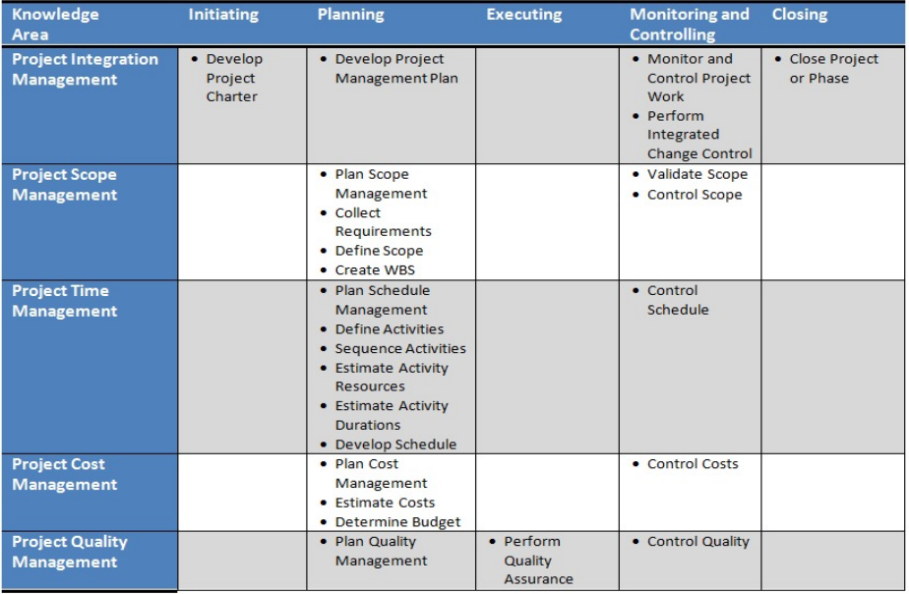

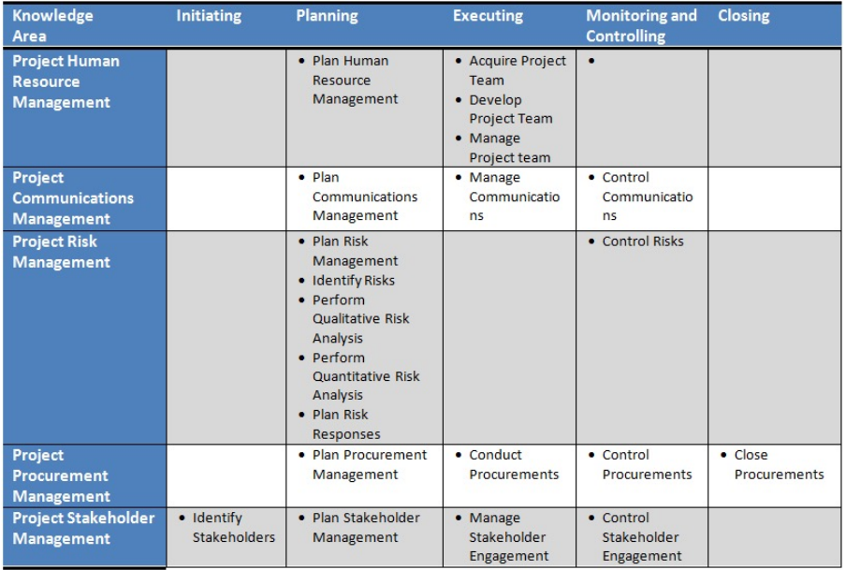

**Scrum Development Overview**

1. Known as an Agile method
2. Used when requirements are difficult to define or subject to rapid change
3. Iterative approach
4. Uses sprints or 2 to 4-week cycles
5. Roles
   1. Product owner
   2. Scrum Master
   3. Development Team
      1. May include specialist roles such as developer, subject matter expert
6. Priorities: stories are either on the:
   1. Front burner (currently working on)
   2. Back burner (next up)
   3. Fridge (for later)
7. Priorities are revisited before each new sprint
8. Daily stand-up meeting (short meeting with fixed agenda)
   1. What was done yesterday
   2. What will be done today
   3. Are there any problems the scrum master must address, such as resource issues out of the control of the team

**Scrum Development Caveats**

1. Requires committed, mature developers
2. Major work must still be done upfront
3. Needs the commitment and involvement of the Product Owner
4. Best for products that require frequent updates
5. Not so good for large, totally new products that will not allow frequent updates after release

**The Project Management Office (PMO)**

1. Medium and large organizations
2. Typical objectives
   1. Align projects with organizational objectives
   2. Set standards for projects
   3. Provide resources to project managers
   4. Provide training and mentorship
   5. Provide facilitation
   6. Stay abreast of best practices in Project Management
   7. Repository for project reports and lessons learned

**Framework for Project Management**

1. Project management as a profession
2. The Project Management Institute
3. Project Management Certifications: PMP, CAPM
4. PMBOK overview: ten knowledge areas; five process groups
5. Scrum methodology
6. The Project Management Office